

Year 7 Transition – ICT Task 1

A Simple Search Process

Learning Intention:

Success Criteria:

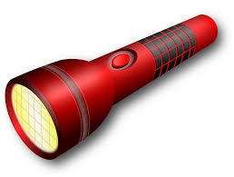
Clarify

What information are you looking for? Consider keywords, questions, synonyms,
alternative phrases etc.

- Your research topic is ‘Laboratory eyewash station’.
- Make a mindmap of the topic you are learning about. This could be either on paper or using an online tool.
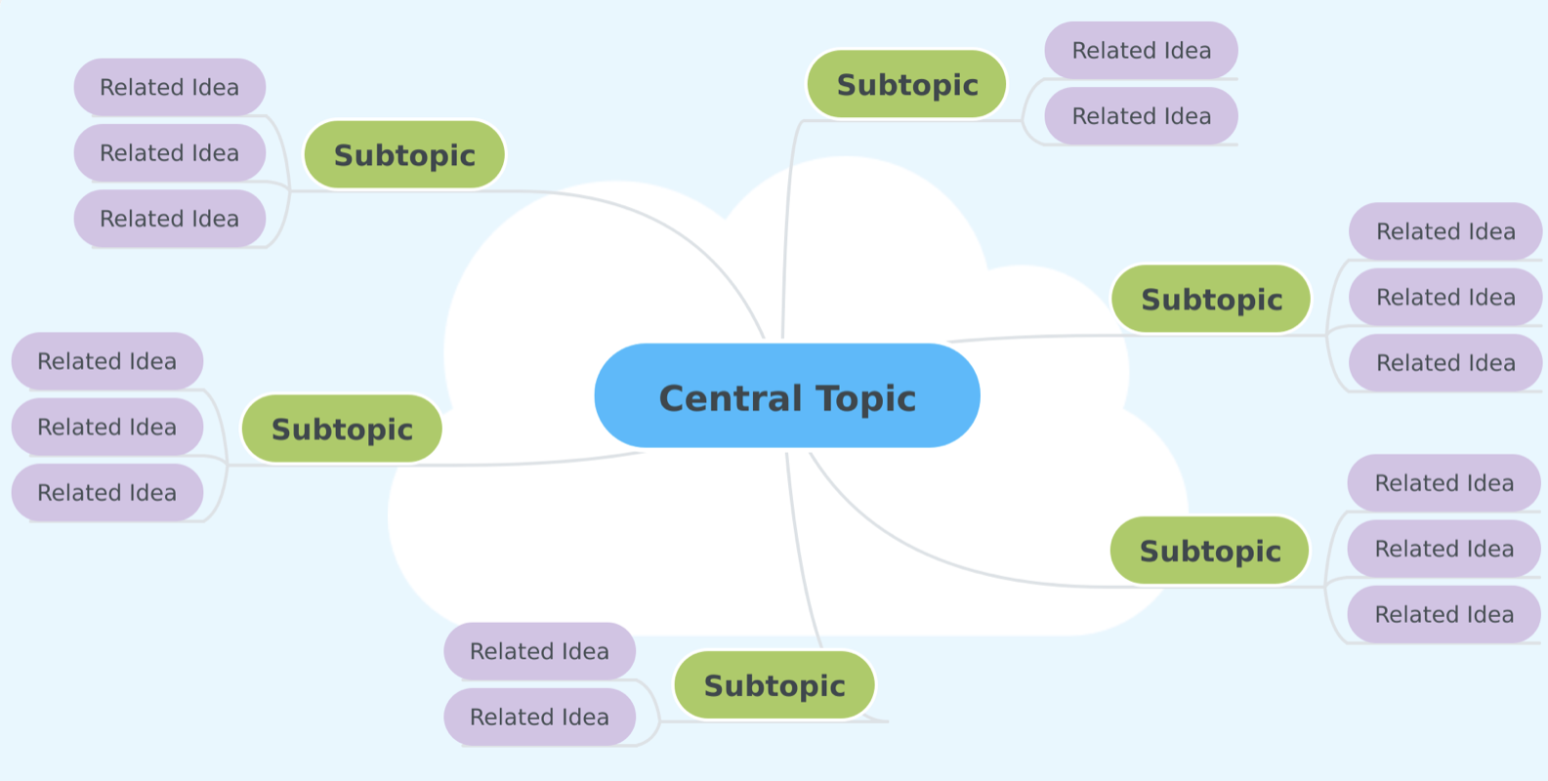

- Write as many different questions as you can think of relating to the topic. Underline the keywords in each question.

- Write down 10 words to describe the topic. Come up with synonyms for these words using a tool like Thesaurus.com.


Search

What are the best words you can type into the search engine to get the highest quality
results?

- Test two search engines with the query (e.g. Google and Yahoo). Do they give the same results?

- Compare two searches – one using more relevant keywords than the other. Discuss the difference.

- Try two searches where one phrase is in quotation marks and the other is not. Discuss the difference.

- Write a question in Google with minor spelling or punctuation errors. What happens?

- Explore how Google uses autocomplete to suggest searches quickly. Try it out and discuss.

- Experiment with typing some questions into Google that have a clear answer. Look at the different ways the answers are displayed instantly within the search results -- dictionary definitions, image cards, graphs etc.



Investigate

What search results should you click on and explore further?

- List/research popular domains. Discuss if any may be more reliable than others (e.g. .gov or .edu).

- Discuss (or research) ways to open Google search results in a new tab to save your original search results.

- Try out a few Google searches and look for advertisements within the search results. Where are they?

- Look at ways to filter search results by the tabs at the top of the page (i.e. news, images, maps).

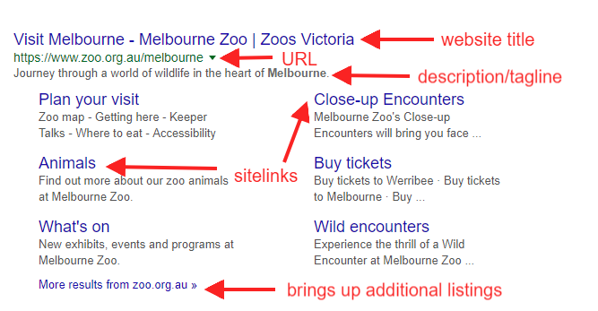

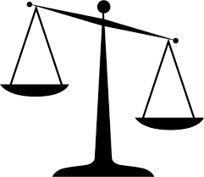
Evaluate

Once you click on the link, how do you know if it offers the information you need?

- Read two articles on the same topic (laboratory eyewash station). Make a Venn diagram comparing the similarities and differences.

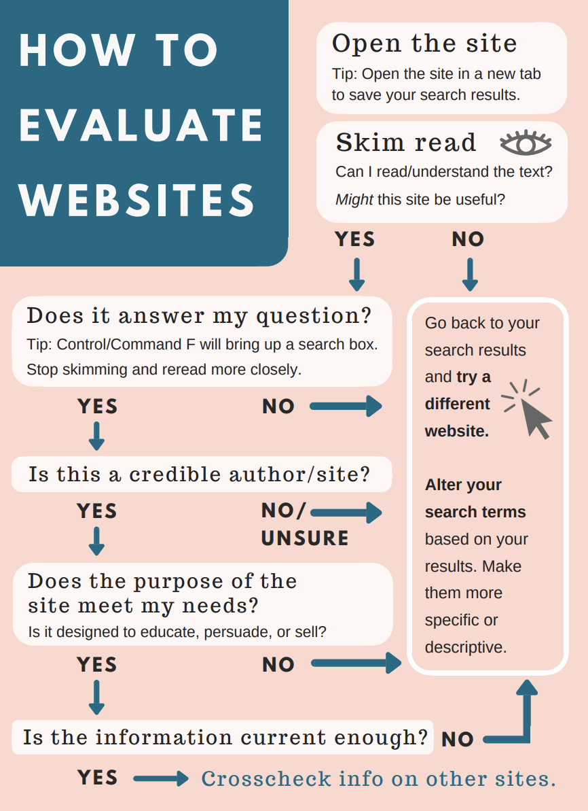

Cite
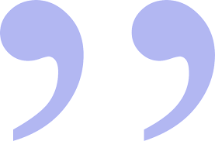
How can you write information in your own words (paraphrase or summarise), use direct
quotes and sources?

- Look up the definition of plagiarism using a variety of sources. Write the meaning in your own words.

- What is the difference between paraphrasing and summarising?

- Read a short article and create a summary that would be considered plagiarism and one that would not.

Why must I cite my sources?
- I cannot claim the work or ideas of someone else as my own
- Plagiarism is not just when I directly copy words from someone else's work. Plagiarism is also when someone else's work is paraphrased or their ideas are used and claimed as my own
- Referencing has a positive effect and adds credibility to my work
- When I reference correctly, I am demonstrating that (a) I have read widely on the topic and (b) that I am supporting my hypotheses with comments from expert authors and/or reliable sources
- Correct referencing allows the marker/reader to follow-up my references and check the validity of my arguments for themselves.

Surname | Initial | Title of page | Full title of website | Date Written | Internet Address | Date of visit
Brown | J. | ‘Things in Space’ | Astronomy Facts | 1998 | http://www.astronomyfacts.com | 31 July 2019

Extension activities

- Try the AGoogleADay.com daily challenges to improve your search skills.

- Learn how to use split screen to have one window open with your research, and another open with your notes (e.g. a Google spreadsheet, Google Doc, Microsoft Word or OneNote etc.).

